Elevational distribution patterns differ between exotic and native birds in Reunion Island

Jacques Tassin¹, Philippe Clergeau² & Gérard Balent³

¹Centre de Coopération Internationale en Recherche Agronomique pour le Développement, Centre international de Baillarguet, TA 10/D, 34398 Montpellier, France
²Institut National de Recherche Agronomique, Station SCRIBE, Campus de Beaulieu, 35042 Rennes Cedex, France
³Institut National de Recherche Agronomique, UMR 1201 Dynamiques Forestières dans l’Espace Rural INRA-INPT/ENSAT, Chemin de Borde Rouge, BP 27, F-31326 Castanet-Tolosan, France

Correspondence author: J. Tassin, e-mail: tassin@cirad.fr

Abstract: Although biological invasions are one of the most important changes in ecological dynamic, they have been rarely investigated along elevational gradients. The objective of this study was to compare the distributions of exotic versus native birds on a same broad elevational gradient. Field studies were conducted on the leeward side of Reunion Island (Mascarene Archipelago, Western Indian Ocean) between 20 and 2880 m at 363 sampling points. Species richness and abundances of bird species were surveyed during the nesting season using 20 min count at each point. Mean elevational position and elevational amplitude were measured for each species and a Mean Distribution Index was computed as the number of bird species having their mean elevation within each 100 m elevational band. The data show that (1) the elevational variation of native species richness is hump-shaped, whereas the richness of exotic bird species does not vary in the first half of the gradient; (2) the elevational amplitude and maximum elevation do not differ significantly between exotic and native birds, but the mean and minimum elevations are higher for native birds; and (3) the most suitable vegetation types are found in the ‘rural landscapes’ belt for the exotic bird communities, and in the higher belt of ‘forest and pastures’ for the native ones. Even if history can appear too short to permit niche expansion of the more recent introduced species, we can underline the exotic species preference for anthropogenic landscapes and their large elevational amplitude.

Keywords: altitudinal gradient, Indian Ocean, introduced species, Mascarene Archipelago, niche-breadth, species richness.

Résumé: Les invasions biologiques, qui constituent l’un des plus importants changements au sein des dynamique écologiques, n’ont été que rarement envisagées le long de gradients altitudinaux. L’objectif de cette étude était de comparer entre elles les distributions des oiseaux exotiques et indigènes sur un même gradient altitudinal. Les études de terrain ont été réalisés dans la partie sous-le-vent de l’Ile de La Réunion (archipel des Mascareignes, océan Indien occidental) entre 20 et 2880 m et sur la base de 363 points d’écoute de 20 min. La richesse spécifique et l’abondance des oiseaux ont été investiguées durant la période de nidification. La position altitudinale moyenne et l’amplitude altitudinale ont été mesurées pour chaque espèce et, pour chaque bande altitudinale de 100 m, un indice dit de distribution moyenne a été calculé sur la base du nombre d’espèces dont la position altitudinale se situait au sein de cette même bande. Les résultats montrent que (1) la variation altitudinale de la richesse spécifique se présente comme une courbe en cloche, tandis que la richesse spécifique des oiseaux exotiques ne varie pas dans la première moitié du gradient ; (2) l’amplitude alitudinale et l’altitude maximale ne diffèrent pas de manière significative entre les espèces exotiques et indigènes, mais les altitudes moyenne et minimale sont plus élevées pour le espèces indigènes ; (3) les types de végétation les plus accueillants restent les paysages ruraux s’agissant des espèces exotiques, et la ceinture végétale constituée de forêts et de pâtures pour les espèces indigènes. Les espèces exotiques, bien qu’introduites trop récemment pour avoir élargi leur niche, présentent une préférence pour les paysages anthropiques, de même qu’une amplitude altitudinale élevée.

Mots-clés: gradient altitudinale, ocean Indien, espèces introduites, archipel des Mascareignes, expansion de niche, richesse spécifique.

Introduction

The conspicuous ecological changes that occur along elevational gradients has recently drawn the attention of an increasing number of researchers. Most hypotheses which attempted to explain biological responses to elevational gradients were formally based on a single bio-physical factor such as productivity, habitat diversity, environmental stress, resource availability or competition (e.g. Rahbek, 1995; Heaney, 2001). Others underlined the role of anthropogenic pressure or ecological and evolutionary processes (e.g. Myers & Giller, 1988).
Surprisingly, studies on species distribution along elevational gradients scarcely pay attention to the status of the involved species, i.e. either exotic or native (but see Tassin & Rivière, 2003; Tassin et al., 2004), despite of the increased importance of the impact of introduced species on biodiversity (Vitousek et al., 1997). The same can be said of studies on latitudinal gradients (but see Sax, 2001). Considering the theoretical framework of biological invasions, investigations on the distribution of exotic species along broad ecological gradients should enable us to predict invasion patterns.
Birds, widely introduced throughout the world and having colonized most vegetation types (Long, 1981), are a relevant taxon for studying the comparative distribution of exotic versus native species along elevational gradients. Exotics may be defined as species that have been introduced by humans, or have been able to expand their range because of anthropogenic disturbances, into geographical regions in which they were not historically present (Sax, 2001). Birds have been widely used as models in studies on the variation of species richness with elevation (Thiollay, 1980; Patterson et al., 1998; Benning et al., 2002 ; Prodon et al., 2002). The elevational range of bird communities is also of special interest as it is one of the dimensions of the niche of a species, and it is linked to flexibility in habitat or food choices, ability to coexist with different species, and physiological tolerance (Prodon et al., 2002). Last, the mean elevational position can be considered to be an indicator for determining one of the optimal vegetation types of a species.
In this paper, we compare elevational patterns of bird species along an elevational gradient sufficiently broad to reveal possible different responses between exotic and native birds. We chose to analyse a slope of Reunion Island that presents one of the widest bio-climatic gradients within any oceanic island, i.e. 0 to more than 3000 m on a distance of only 20 km. In addition, studies in this kind of oceanic islands may contribute to understanding the potentially huge impact of biological invasions (Loope & Mueller-Dombois, 1989). This paper focuses on a specific goal: do elevational distribution patterns vary between exotic and native bird communities? Consequently, for each one of these groups, we compared species richness pattern; maximal elevation, minimal elevation, elevational amplitude, and the variation of mean elevational positions with elevational bands. We used the word elevation instead of altitude, though both elevation and altitude are used as synonyms, as elevation is meters above sea level and is more correct than altitude which is meters above ground.

material and methods

Studied area
Reunion Island is part of the Mascarene volcanic archipelago, situated in the Western Indian Ocean (55°30’ E and 21°05’ S)(Fig. 1). This oceanic island appeared three million years ago. In the centre of the island, a plateau (Plaine des Caffres, ≈2000 m) is flanked by two volcanoes (Piton de la Fournaise, 2631 m; Piton des Neiges, 3069 m), the sides of which slope steeply towards the sea. There is a very steep climatic gradient: the average minimum ground temperature falls below 0°C above 1500 m in August, above 1800 m from June to October, and above 2300 m all year round; at the highest point, the temperature ranges from -10°C to +26°C (Cadet, 1974; Raunet, 1991).
The studied area, located on the leeward side of the island had a slope of about 0.15 m per m and an annual rainfall ranging from 500 mm at sea level to 2000 mm on the highest mountain slopes (Raunet, 1991). The land is roughly organized through a land use gradient into a succession of elevational belts (Cadet, 1980): urbanised areas (0-50 m a.s.l.), herbaceous savannah (50-300 m), sugarcane monoculture (300-800 m), rural landscapes with diversified crops (800-1200 m), primary forest mixed with pastures and planted forests (1200-1800 m), heathlands dominated by ericaceous plants (1800-2600 m), and bare soils with a very sparse vegetation of herbaceous species (2600-3069 m) (Fig. 1). Above 1200 m, about 60 % of the original primary forest and 80 % of the original heathlands have been preserved from clearing (Strasberg et al., 2006).

methods

Sampling
The transect was sampled through one survey during the breeding season (December, 1997 - April, 1998), using 363 sample points spread along an elevational gradient from 20 m to 2880 m (Fig. 1). Further prospecting between 2880 and 3069 m (Piton des Neiges) revealed no bird presence. This was due to of a lack of vegetation, except for scarce amounts of native herbs and weeds (Tassin & Rivière, 2003). Sampling points were equally distributed all along the elevational gradient, with a mean elevational distance of 8 m and a distance of at least 250 m between two successive count points, a mean sampling pressure of 12.7 count points per 100m elevational band, and covering the overall diversity of vegetation types. Under-sampling of some elevational bands or vegetation types would have brought about an under-evaluation of species richness along the considered ecological gradient (Prodon & Lebreton, 1981; Rahbek, 1997; Patterson et al., 1998). The position of sampling points was retained following detailed maps (scale 1:25000). Depressions, ridges and mires were avoided in order to avoid extremely wet or dry places. We also avoided places too close to feeding troughs in grasslands as they attract granivorous bird species. We assume that most of the birds were sampled on or near their nesting sites.
However, an equal sampling effort may result in sampling unequal proportions of the total richness, which may in turn affect the elevational species richness pattern once interpolation is used (Colwell & Hurtt, 1994). One reason for this is that, in this case, richness towards the boundaries only consists of observed species, whereas at other elevations richness consists of observed species plus the species added by interpolation (Grytnes & Vetaas, 2002). In this study, we have tried to correct this bias (1) by sampling the different ecosystems found at each 100m elevational band so as not to miss individual bird species specific to individual ecosystems, and (2) by interpolating species distribution within each 100 m elevational band where an individual bird species occurs, instead of the part of the gradient between its upper and lower elevational limits.
Data were collected using the point count method during the nesting period (Blondel et al., 1970). Data were collected between 5.30 a.m. and 10.30 a.m. Elevation was recorded using an electronic altimeter of a ± 10 m accuracy. The position of each point was marked on a map (1:25000). Every terrestrial bird species observed within a radius of 150 m around each count point was recorded on a paper form. The duration of each count was 20 minutes. The nomenclature and biogeographical status of the birds was described in accordance with Sinclair & Langrand (1998).

Analysis
The elevational patterns of species composition of exotic versus native bird communities were based on elevational bands of 100 m and were investigated in three different ways: (1) the variation of species richness with elevation, (2) the response of species to elevation (elevational amplitude, mean elevation, median amplitude and upper-lower elevations), and (3) the current optimal elevational band of each species in terms of reproductive success and fitness.
Actually, most studies on elevational gradients focus on the variation of species richness with elevation but do not give any information on the mean elevational position, that is to say the optimal elevational position of the studied taxa (Rahbek, 1997; Paterson et al., 1998; Odland & Birks, 1999; Kessler, 2000; Grytnes, 2003). In terms of conservation, it appears sound to identify those elevational bands that are optimal for a great number of species, even if we must consider that some species have been displaced from their optimal location by human land use and conversely that human land use has added resources to the landscape. The investigation of the elevational distribution of the mean elevations of studied species yields information that the mere examination of variation of species richness with elevation will not provide. Therefore, for each 100m elevational band b_{i}, we computed a Mean Distribution Index MDI(b_{i}) which is the number of bird species having their mean elevation in band b_{i}. Only species recorded in more than five point counts were used in the computation of SI.
Comparisons between exotic and native species were performed using the Man-Whitney test. Correlations were computed using Pearson product-moment correlation coefficients and tested using the Bonferroni adjusted probability. All statistical analyses were computed using SYSTAT software (SYSTAT, 1999).

results
We detected 23 bird species with a mean of 4.3 species per point and 9.5 species per elevational band along the gradient. There was a negative correlation between the number of species and the elevation (r = -0.678, P < 0.001). 15 species were exotic and 8 native (Table 1).
The variation of species richness with elevation differed significantly between exotic and native species (Fig. 2), as exotic species decreased regularly along the gradient (r = - 0.836, P < 0.001), whereas native ones did not (r = -0.249, P = 0.176). According to richness patterns, four zones could be defined: (1) from 0 to 1000 m, there was a significant difference between exotic and native species, both in the number of species contacted (df = 9, P < 0.001) and in their variation pattern, as native species increased with the elevational gradient from two to seven while the exotic ones remained at a high level (around 9 species ); (2) from 1000 to 1500 m, richness of both exotic and native species presented a peak (around 9 and 6 species, respectively); (3) from 1500 to 2500 m, richness in exotic and native species decreased to 1-3 species; and (4) from 2500 to 3000 m, no birds were observed.
The elevational amplitude values were high. Elevational amplitude exceeded 2000 m for five species and 1000 m for 15 species (Table 1). The largest elevational amplitude observed within the exotic species was registered by Acridotheres tristis (77.5 % of the whole gradient), and within the native species by Zosterops borbonicus (86.0 %). The lowest elevational amplitude observed within the exotic species was registered by Perdicula asiatica (7.8 %), and within the native species by Circus maillardi (18.6 %). Elevational amplitude and maximum elevation did not differ significantly between exotic and native species (P = 0.499 and P = 0.237, respectively). However, the mean elevation and minimum elevation for the native species were higher (P = 0.018 and P = 0.020, respectively). Maximum elevation was strongly correlated with elevational amplitude (r = 0.844, p < 0.001).
Mean and median elevations were highly correlated (r = 0.988, P < 0.000), confirming the appropriateness of the sampling design, which consisted of plots equally distributed along the elevational gradient. The distribution of mean elevations for bird species along the gradient was highly concentrated between 1000 and 1500 m, with the exception of three exotic species (Fig. 3). The mean elevational range of the exotic species Perdicula asiatica was surprisingly low, and was the only one positioned in the ‘urbanism and savannah’ belt (50-300m). Similarly, the mean elevational range of Ploceus cucullatus made it the only species positioned in the ‘sugarcane’ belt (300-800m), although it was localised in its upper limit. The ‘rural landscapes’ belt (800-1200m) covered the mean elevational ranges of nine exotic and two native birds. Last, five native but only one exotic species had their mean elevational range in the ‘forest mixed and pastures’ belt (1200-1800m).
The Mean Distribution Index MDI presents a main peak between 1000 and 1500 m, which corresponds to the upper limit of ‘rural landscapes’ belt (Fig. 4). The maximum SI value occurred in the 1100-1200m band (‘rural landscapes’ belt) for exotic species, and in the 1300-1400m band (‘forest and pastures’ belt) for the native species. The sugar cane belt appeared to be unsuitable for both exotic and native birds in our study site.

discussion
Our results show that the elevational distribution patterns of exotic and native species differed within bird communities: (1) the elevational variation of native species richness was hump-shaped, while the richness of exotic bird species did not vary much in the first half of the gradient; (2) elevational amplitude and maximum elevation did not differ significantly between exotic and native birds, but the mean and minimum elevations were higher for the native birds; (3) the vegetation types most colonized by the exotic birds were found in the ‘rural landscapes’ elevational belt, and in the ‘forest and pastures’ elevational belt for the native ones.
The occurrence of a peak in species richness at mid-elevation is commonly observed in elevational gradient studies (Shmida & Wilson, 1985; Rosenzweig, 1992; Rahbek, 1997). No convincing environmental factors have been identified to explain this humped relationship between species richness and elevation (Rahbek, 1997). A possible common factor that may contribute to such a peak is the geometric constraint on species ranges (Colwell & Hurtt, 1994; Rahbek, 1997; Hawkins, 1999; Tassin & Rivière, 2003). Considering the only native species, the deforestation in lowlands during the last centuries has contributed to make many species to disappear (Barré et al., 1996). From an other point of view, we can suggest that speciation rates increase with elevation and peak at intermediate elevations (Lomolino, 2001). Thus, the combination of area and isolation may be more optimal for the persistence and divergence of native species. The effect of a temperature cycle on elevational bird zonation, taking into account the late glacial-interglacial cycles which eliminated the lower and higher ranging species from the elevational gradient, may also represent a relevant historical factor explaining such a mid-elevational peak in native species (Prodon et al., 2002).
The variation of species richness differed between native and exotic bird species, in accordance with the lack of any general models able to capture the variation of specific richness with elevation (Rahbek, 1995; Lawton et al., 1998; Lomolino, 2001). Our results show that a bird’s status (either exotic or native) will determine how it uses a land use gradient provided by human activity along an elevational gradient.
The distribution of the mean elevation of each bird species was notably non-uniform. This can be explained by both bio-physical and historical factors.
Some vegetation types offered a poor level of resources and were under-utilised by birds. Following the destruction of native forests, the omnipresence of sugarcane and the extension of an urban environment, no mean elevation of any bird species was recorded in the sugar belt, except for the exotic Ploceus cucullatus which was indeed localized at the upper edge of it. The only recorded species linked to a lowland vegetation type was the exotic Perdicula asiatica, which was strictly restricted to herbaceous savannah.
The ‘rural landscapes’ belt (800-1200m) contained the mean elevational ranges of nine exotic and two native birds, making this part of the gradient highly invasible and moderately convenient in terms of sheltering native birds. Conversely, five native but only one exotic species had their mean elevational range in the ‘forest and pastures’ belt (1200-1800m). This part of the gradient seems much less invasible than the adjacent ‘rural landscapes’ belt.
Indeed, three hypothesis can be proposed to explain why the mean and minimum elevations of the native species were higher than those of the exotic ones: (1) game removal and the extinction of native species living in lower landscapes and in primary forests which had been heavily destroyed, resulted in half of the bird species becoming extinct (Barré et al., 1996); (2) the necessity for native species to explore sub-optimal habitats following deforestation, poaching and anthropogenic pressures (van Riper et al., 1986; Cheke, 1987); and (3) strong competition by the exotic species towards the native species, in accordance with the theory of the taxon cycle (Ricklefs & Cox, 1978; Brown & Gibson, 1983). However, previous studies on the introduction of birds into the Mascarene Archipelago have shown that intra-species competition within exotic species may be stronger than inter-species competition between exotic and native species (Simberloff, 1992; Moulton et al., 1996) and that bird competition was rather low in islands with low species richness (Mountainspring & Scott, 1985; Blondel et al., 1988). Furthermore, within the 17 exotic species naturalised in Reunion Island, none were observed in native forests during our field survey, in accordance with other studies (Ehrlich, 1989; Loope & Mueller-Dombois, 1989; Simberloff, 1992). Consequently, the differences in the respective mean and minimum elevations recorded for exotic and native birds seems to be related to the environmental and historical background of each species grouping, rather than being due to the effects of competition.
Our results also showed that the elevational amplitudes of birds were high and that this was true of both exotic and native birds. Both exotic and native bird statuses appear to have benefited from the niche expansion process. According to the ‘taxon cycle’ hypothesis (Wilson, 1961; Greenslade, 1968; Cox, 1978), niche expansion is prevalent among colonizers; but isolated species tend in the long term towards differentiation, niche narrowing, range restriction, and eventual extinction. According to MacArthur and Wilson (1967), an immigrant population contracts its niche on meeting more competitors, and expands its niche when meeting less. In addition, the repetition of climatic cycles on an island tends to broaden the elevational ranges, by both selecting those colonizers that already have wide ranges in the mainland, and by exerting a selective pressure in favour of the broadening of the habitat-niches of the residents (Prodon et al., 2002). In our case study, both exotic and native birds may have broadened their elevational ranges through colonization thanks to the lack of competition and from climatic cycle effects. Some recently introduced species, such as Pycnonotus jocosus (Clergeau & Mandon-Dalger, 2001), have yet to fully display an ability to expand their niche. A consequence of the niche-expansion is the occurrence of a peak in species richness at mid-elevation. Indeed, the wider the elevational range of a species, the higher is the probability of observing this species at mid-elevation (Colwell & Hurtt, 1994; Tassin & Rivière, 2003).
The strong correlation observed between maximum elevation and elevational amplitude is consistent with ‘Rapoport’s rule’, which states that high latitudinal species have a higher ecological tolerance and occur in a wider elevational range than low latitudinal species (Stevens, 1992). Moreover, this correlation can be associated with the observation that the endemism level within bird species is linked to the maximum elevation of the island (Adler, 1994). High elevational bands have higher endemic species richness than low elevational bands, and consequently, they include more bird species with high elevational amplitudes. This is especially evident on Reunion Island where a major part of the endemic bird species at low elevations has disappeared.
In conclusion, we have shown a clear difference between native and exotic species distribution in accordance with elevational gradient. Even though there has not been enough time for niche expansion of the more recent introduced species, we can still underline the exotic species’ preference for anthropogenic landscapes and note their large elevational amplitudes and similarity to the more generalist native species.

Aknowledgements
We thank Vincent Bénard and Jean-Noël Rivière for field assistance. We are also grateful to the two anonymous reviewers for helpful comments on the manuscript. Financial support was given by Région-Réunion.

Literature cited
Adler, G. H. 1994. Avifaunal diversity and endemism on tropical Indian Ocean islands. Journal of Biogeography, 21: 85-95.
Barré, N., Barau, A. & Jouanin, C. (1996) Oiseaux de la Réunion. Editions du Pacifique, Paris.
Blondel, J., D. Chessel & B. Frochot, 1988. Bird species impoverishment, niche expansion, and density inflation in Mediterranean island habitats. Ecology, 69: 1899-1917.
Blondel, J., C. Ferry & B. Frochot, 1970. La méthode des indices ponctuels d’abondance (I. P. A.) ou des relevés d’avifaune par « stations d’écoute ». Alauda, 38: 55-71.
Brown, J. H. & A. C. Gibbon, 1983. Biogeography. C. V. Mosby, St Louis, Missouri.
Cheke, A.S., 1987. An ecological history of the Mascarene Islands, with particular reference to extinctions and introductions of land vertebrates. Pages 5-89 in A. W.Diamond (ed.). Studies of Mascarene Island Birds (ed. by Cambridge University Press, Cambridge.
Clergeau, P. & I. Mandon-Dalger, 2001. Fast colonization of an introduced bird: the case of Pycnonotus jocosus on the Mascarene Ilands. Biotropica, 33: 542-546.
Colwell, R. K. & G. C. Hurtt, 1994. Non biological gradients in species richness and a spurious Rapoport effect. The American Naturalist, 144: 570-595.
Ehrlich, P. R., 1989. Attributes of invaders and the invading processes: vertebrates. Pages 315-328 in J.A. Drake, H.A. Mooney, F. Di Castri, R.H. Groves, F.J. Kruger & M. Rejmánek (eds.). Biological invasions: a global perspective. John Wiley & Sons, New York.
Greenslade, P. J. M., 1968. Island patterns in the Solomon Islands bird fauna. Evolution, 22, 751-761.
Grytnes, J. A., 2003. Species-richness patterns of vascular plants along seven altitudinal transects in Norway. Ecography, 26: 291-300.
Grytnes, J. A. & O. R. Vetaas, 2002. Species richness and altitude: a comparison between simulation models and interpolated plant species richness along the Himalayan altitude gradient, Nepal. The American Naturalist, 159: 294-304.
Heaney, L. R., 2001. Small mammal diversity along elevational gradients in the Philippines: an assessment of patterns and hypotheses. Global Ecology and Biogeography, 10: 15-39.
Janzen, D. H., 1973. Sweep samples of tropical foliage insects: effects of season, vegetation types, elevation, time of day, and insularity. Ecology, 54: 687-708.
Lawton, J. H., D. E. Bignell, B. Bolton, G. F. Bloemers, P. Eggleton, P. M. Hammond, M. Hodda, R. D. Holt, T. B. Larsen, N. A. Mawdsley, N. E. Stork, D. S. Srivastava & A. D. Watt, 1998. Biodiversity inventories, indicator taxa and effects of habitat modification in tropical forest. Nature, 291: 72-76.
Lomolino, M. V., 2001. Elevational gradients of species-density: historical and prospective views. Global Ecology and Biogeography, 10: 3-13.
Long, J. L. (1981) Introduced birds of the world: the worldwide history, distribution and influence of birds introduced to new environments, p. 528. Universe Books, New York.
Loope, L. & D. M. Mueller-Dombois, 1989. Characteristics of invaded islands, with special reference to Hawaii. Pages 257-280 in J.A. Drake, H.A. Mooney, F. Di Castri, R.H. Groves, F.J. Kruger & M. Rejmánek (eds.). Biological invasions: a global perspective. John Wiley & Son, New York.
MacArthur, R. H. & E. O. Wilson, 1967. The theory of island biogeography. Princetown University Press, Princetown, New Jersey, USA.
Moulton, M. P., J. G. Sanderson, & D. Simberlof, 1996. Passeriform introductions to the Mascarenes (Indian Ocean): an assessment of the role of competition. Ecologie, 27: 143-152.
Mountainspring, S. & J. M. Scott, 1985. Interspecific competition among Hawaiian forest birds. Ecological Monographs, 55: 219-239.
Myers, A. A. & P. S. Giller, 1988. Analytical biogeography: An integrated approach to the study of animal and plant distributions, Chapman and Hall, London, UK.
Odland, A. & H. J. B. Birks, 1999. The altitudinal gradient of vascular plant richness in Aurland, western Norway. Ecography, 22: 548-566.
Patterson, B. D., D. F. Stotz, S. Solari, & J. W. Fitzpatrick, 1998. Contrasting patterns of elevational zonation for birds and mammals in the Andes of southeastern Peru. Journal of Biogeography, 25: 593-607.
Prodon, R. & J-D Lebreton, 1981. Breeding avifauna of a Mediterranean succession: the holm oak and cork oak series in the eastern Pyrenees. 1. Analysis and modelling of the structure gradient. Oikos, 37: 21-38.
Prodon, R., J. C. Thibault, & P. A. Dejaifve, 2002. Expansion vs. compression of bird altitudinal ranges on a Mediterranean Island. Ecology, 83: 1294-1306.
Rahbek, C., 1995. The elevational gradient of species richness: a uniform pattern? Ecography, 18: 200-205.
Rahbek, C., 1997. The relationship between area, elevation, and regional species richness in neotropical birds. The American Naturalist, 149: 875-902.
Raunet, M., 1991. Le milieu physique et les sols de l’île de La Réunion. Conséquences pour la mise en valeur agricole, p. 483. CIRAD, Montpellier.
Ricklefs, R. E. & G. W.Cox, 1978. Stage of taxon cycle, habitat distribution, and population density in the avifauna of West Indies. American Naturalist, 112: 875-895.
Rosenzweig, M. L., 1992. Species diversity gradients: we know more and less than we thought. Journal of Mammalogy, 73: 715-730.
Sax, D.F., 2001. Latitudinal gradients and geographic ranges of exotic species: implications for biogeography. Journal of Biogeography, 28: 139-150.
Shmida, A. & M. W. Wilson, 1985. Biological determinants of species diversity. Journal of Biogeography, 12: 1-20.
Simberloff, D., 1992. Extinction, survival and effects of birds introduced to the Mascarenes. Acta Oecologica, 13: 663-678.
Sinclair, I. & O. Langrand, 1998. Birds of the Indian Ocean islands. Struik Publishers, Cape Town.
Stevens, G. C., 1992. The elevational gradient in altitudinal range: an extension of Rapoport’s latitudinal rule to altitude. The American Naturalist, 140: 893-911.
Strasberg, D., M. Rouget, D. M.Richardson, S. Baret, J. Dupont & R. M. Cowling, 2006. An assessment of habitat diversity and transformation on La Réunion Island (Mascarene Islands, Indian ocean) as a basis for identifying broad-scale conservation priorities. Biodiversity and Conservation, 83: 219-226.
SYSTAT, 1999. SYSTAT for Windows, statistics, version 9.0. SPSS Inc., Chicago.
Tassin, J., G. Derroire & J-N. Rivière, 2004. Gradient altitudinal de la richesse spécifique et de l’endémicité de la flore ligneuse indigène à l’île de La Réunion (archipel des Mascareignes). Acta Botanica Gallica, 151: 181-196.
Tassin, J. & J-N. Rivière, 2003. Gradient altitudinal de richesse en plantes invasives à l’île de La Réunion (archipel des Mascareignes, océan Indien). Revue d’Ecologie (Terre Vie), 58: 257-270.
Terborgh, J., 1977. Bird species diversity on an andean elevational gradient. Ecology, 58: 1007-1019.
Thiollay, J. M. (1980) L’évolution des peuplements d’oiseaux le long d’un gradient altitudinal dans l’Himalaya central. Revue d’Ecologie (Terre Vie), 34: 199-269.
Van Riper, C., S. G. Van Riper, M. L. Goff & M. Laird, 1986. The epizootiology and ecological significance of malaria in Hawaiian landbirds. Ecological Monographs, 56: 327-44.
Vitousek, P. M., D’Antonio, C. M., Loope, L. L., Rejmanek, M. & Westbrooks, R. (1997) Introduced species: a significant component of human-caused global change. New Zealand Journal of Ecology, 21: 1-16.
Wilson, E. O., 1961. The nature of the taxon cycle in the Melanesian ant fauna. America Naturalist, 95: 169-193.

Table 1 List of observed species and elevational distribution of species observed more than five times in the study. The elevational belt mentioned in the table corresponds to the mean elevation of the bird species. E: exotic; N: native; US: urbanism and savannah; SC: sugarcane ; RL: rural landscapes; FP: forest and pastures.

Figure 1 Map of Reunion Island and its localisation in the West Indian Ocean; schematic distribution of elevational belts along the elevational transect AB.

Figure 2 The relationship between species richness and elevation on Reunion Island. ( a) exotic species. (b) native species. Symbols represent species richness at the corresponding 100m elevational band.

Figure 3 Mean elevational position of birds along the elevational gradient on Reunion Island. (a) exotic species. (b) native species.

Figure 4 Elevational variation of the Mean Distribution Index SDI (number of species which have their mean elevational position in a given elevational band).
Table 1

Bird species | Status | Total occurrence | Mean  elevation  (m) | Elevational belt | Lower  limit  (m) | Upper  limit  (m) | Elevational  amplitude  (m)
Coturnix chinensis | E | 1 | - | - | - | - | -
Francolinus pondicerianus | E | 2 | - | - | - | - | -
Lonchura punctata | E | 1 | - | - | - | - | -
Phedina borbonica | N | 1 | - | - | - | - | -
Perdicula asiatica | E | 16 | 130 | US | 50 | 290 | 240
Ploceus cucullatus | E | 32 | 795 | SC | 65 | 1345 | 1280
Geopelia striata | E | 109 | 993 | RL | 20 | 1620 | 1600
Turnix nigricollis | E | 41 | 1050 | RL | 35 | 1700 | 1665
Pycnonotus jocosus | E | 72 | 1062 | RL | 65 | 1690 | 1625
Estrilda astrild | E | 88 | 1070 | RL | 60 | 1720 | 1660
Passer domesticus | E | 72 | 1121 | RL | 65 | 1960 | 1895
Circus maillardi | N | 6 | 1125 | RL | 800 | 1370 | 570
Foudia madagascariensis | E | 268 | 1127 | RL | 20 | 2250 | 2230
Collocalia francica | N | 57 | 1131 | RL | 185 | 1660 | 1475
Acridotheres tristis | E | 168 | 1155 | RL | 20 | 2400 | 2380
Streptopelia picturata | E | 34 | 1187 | RL | 100 | 2150 | 2050
Coturnix coturnix | E | 33 | 1191 | RL | 320 | 1700 | 1380
Zosterops borbonicus | N | 229 | 1215 | FP | 60 | 2700 | 2640
Terpsiphone bourbonnensis | N | 18 | 1337 | FP | 900 | 1680 | 780
Saxicola tectes | N | 202 | 1350 | FP | 270 | 2880 | 2610
Hypsipetes borbonicus | N | 67 | 1396 | FP | 620 | 2560 | 1940
Zosterops olivaceus | N | 45 | 1404 | FP | 620 | 2600 | 1980
Margaroperdrix madagascariensis | E | 5 | 1465 | FP | 1240 | 1705 | 465

Figure 1

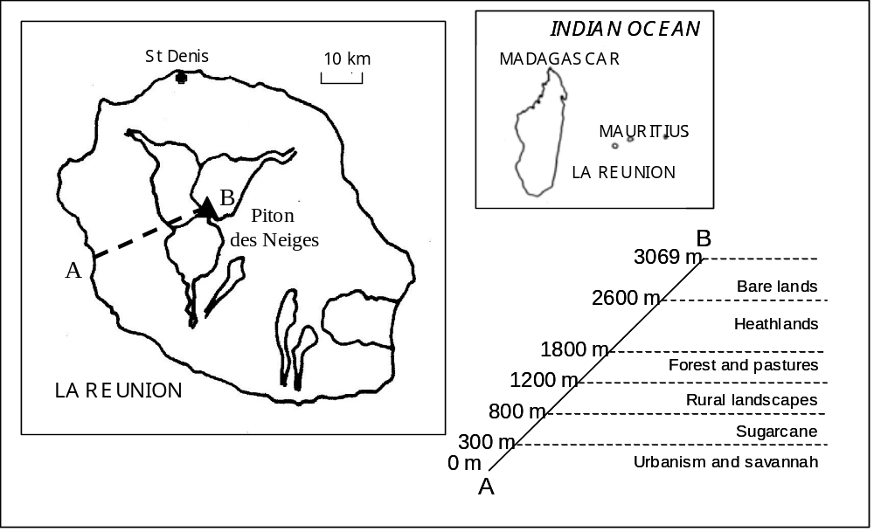

Figure 2

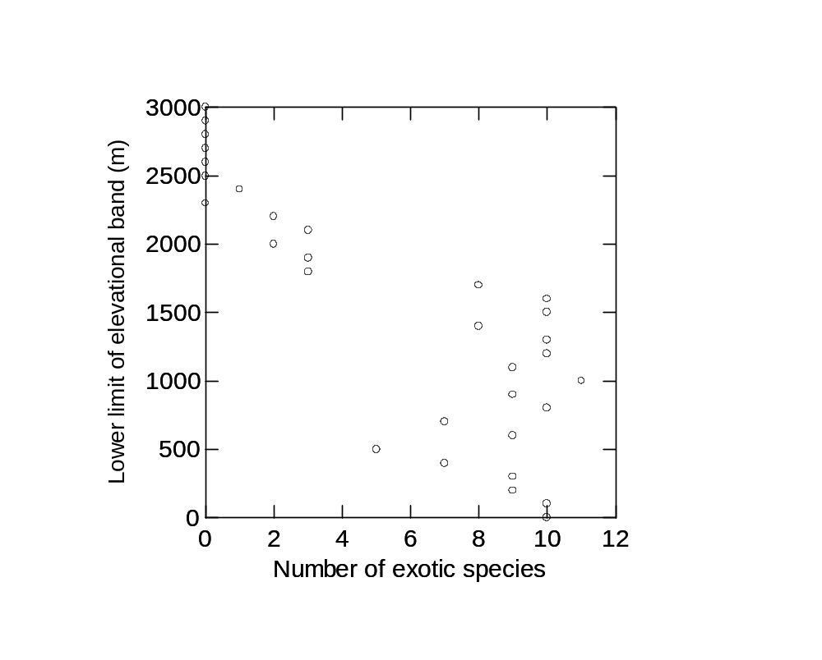

(a)

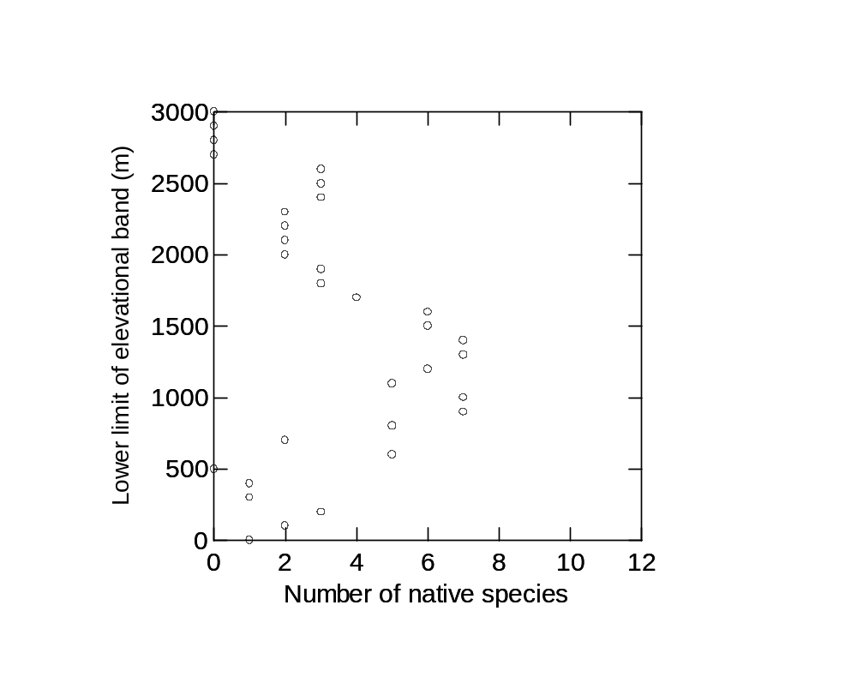

(b)

Figure 3

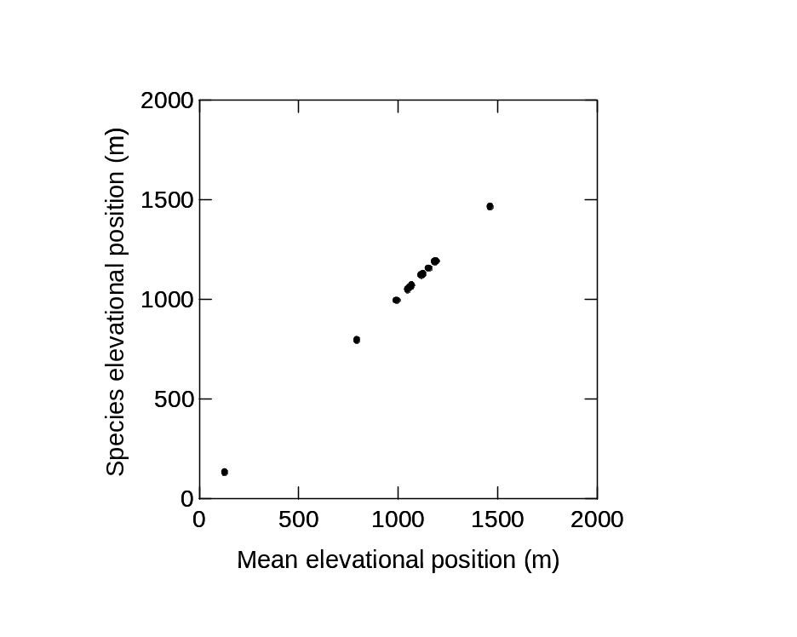
(a)
(b)

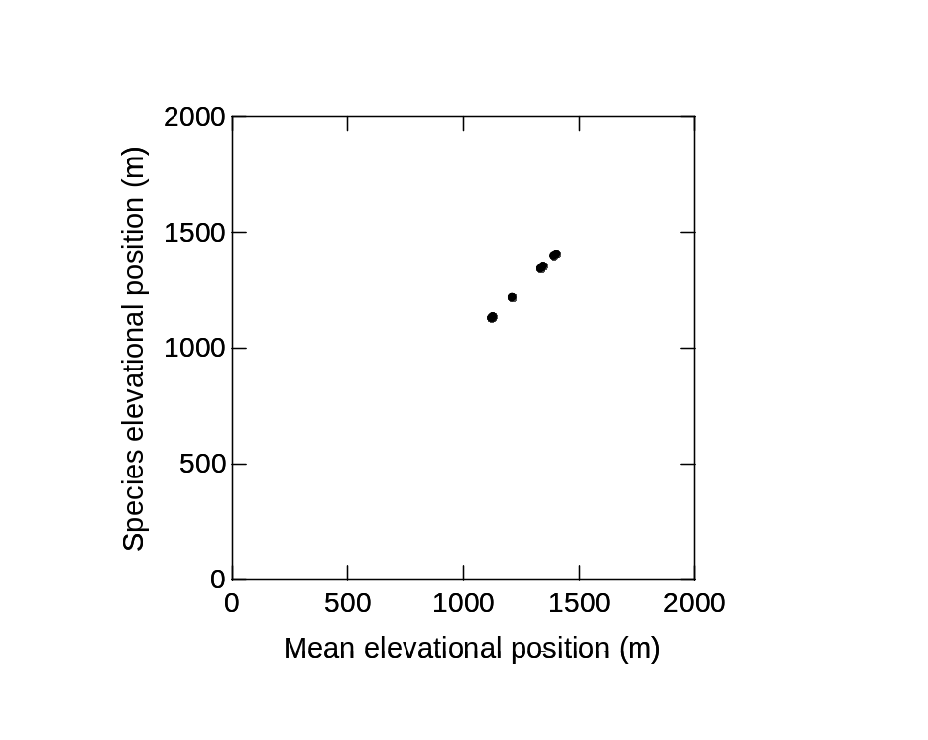

Figure 4

